**Pivotal Cloud Foundry**

What is Cloud Foundry?

Cloud foundry is an open source platform as service offering provided by pivotal

Let’s discuss what is platform as service offering?

We have several cloud platform like Google cloud, Amazon Cloud and Spring Cloud and pivotal Cloud where we can deploy our micro services

Or any application but each cloud factory have their own patterns to configure, deploy, managing etc.

So each of them offering service us to deploy application.

So let’s see what are the service they providing and how they categorized, normally it divided in 3 types

1. Infrastructure

2. Platform

3. Software

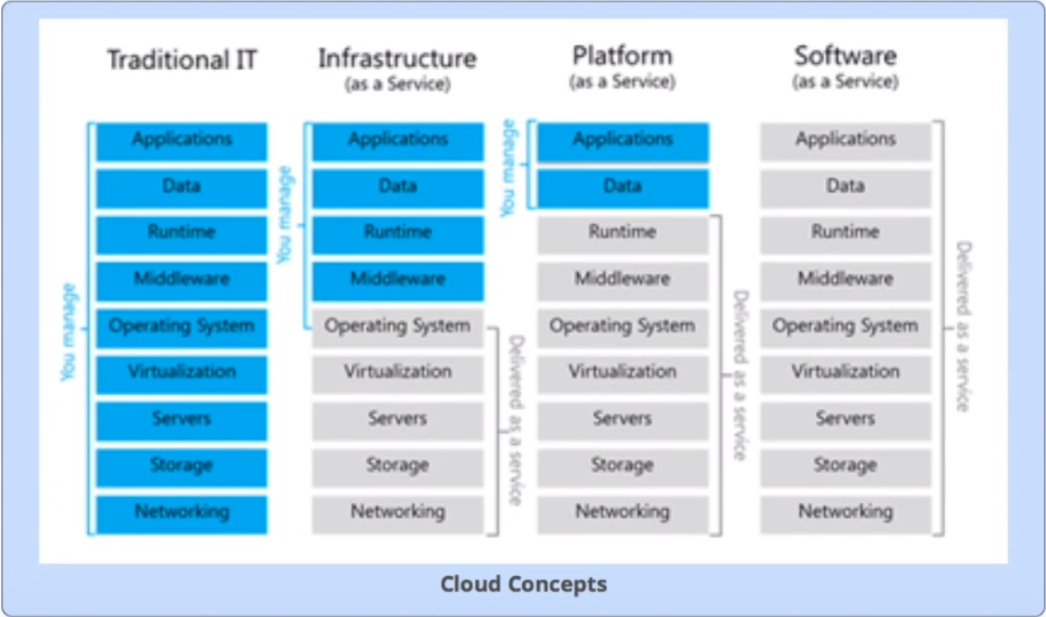

So discuss one by one.

As per architecture normally we required few support to deploy our application in any environment

1. Application
2. Data
3. Runtime
4. Middleware
5. Operating system
6. Virtualization
7. Servers
8. Storage
9. Networking

Now let’s see what each service offering

**Infrastructure Service Offering**

1. Application
2. Data
3. Runtime
4. Middleware
5. Operating system
6. Virtualization
7. Servers
8. Storage
9. Networking

Infrastructure provides only green mark fields Rest all we need to manually configure in that cloud environment

Like: workspace, runtime environment and API related configure that we need to do manually

The Best Example is AWS (Amazon Web service) if any one worked on AWS they marked everything we need to set there like Virtual box

**Platform Service Offering**

1. Application
2. Data
3. Runtime
4. Middleware
5. Operating system
6. Virtualization
7. Servers
8. Storage
9. Networking

Platform provides only green mark fields Rest all we need to manually configure in that cloud environment

So here you need to bother about only your application set up and dataset rest all inbuilt by platform service provider like you can choose your own platform like java, python or any tech they have multi environment supports

The best Example is GCP and Pivotal Cloud Foundry and Cloud Foundry have to great support to Our Spring Cloud

**Software Service Offering**

1. Application
2. Data
3. Runtime
4. Middleware
5. Operating system
6. Virtualization
7. Servers
8. Storage
9. Networking

Software service provides all the required environment

Best Example is Google docs

So now in this article am going to explain Platform Offering Service that with Pivotal Cloud Foundry

So what we need to manage for this only our application and data. Rest all will provide by Cloud Foundry

Before Start with application let’s Set up the environment to work on Cloud Foundry

Steps:

1. Install CF-CLI (Cloud Foundry Command Line Interface from below link <https://docs.cloudfoundry.org/cf-cli/install-go-cli.html>
2. Create one Account in Pivotal Cloud Foundry it is free for trial up to 2 GB from below link <https://account.run.pivotal.io/z/uaa/sign-up> Remember your email id and password for further used
3. Now Sign in using email and password which you entered while create account 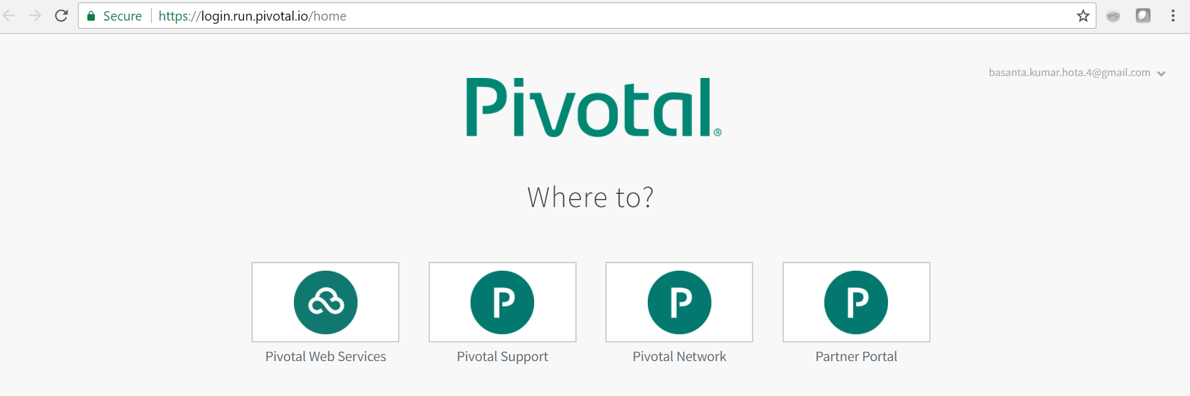click on Pivotal Web Service
4. Then It will ask you to Add Development Environment name , so mention I mentioned BasantJava like below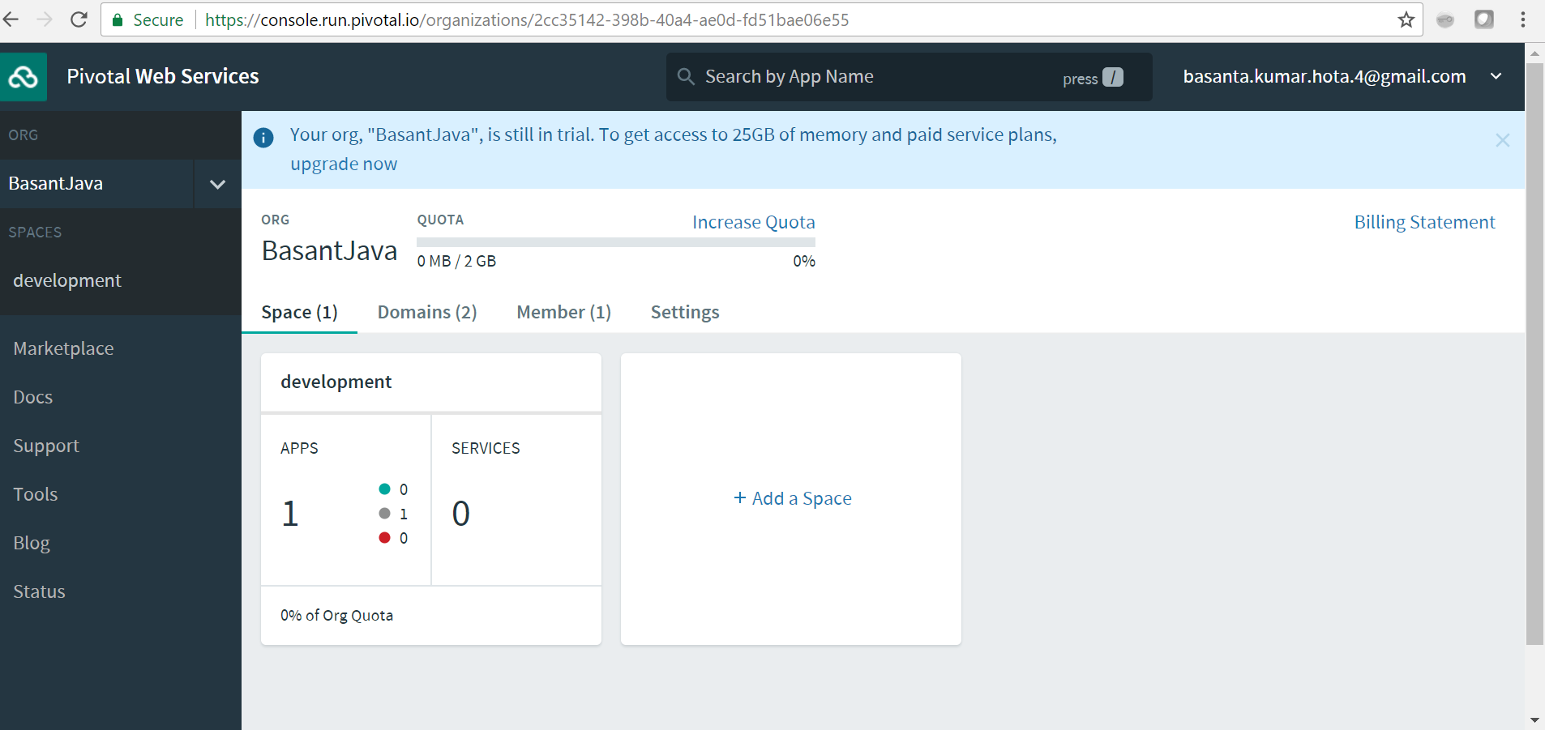As I already deployed one small application for testing purpose it showing APPS as 1, but when you initially open it should be 0 with full 2GB space like above image
5. Now Environment is Ready let’s start to develop one small hello-world application

**Application Development Steps:**

1. Open Eclipse Workspace then click on file >New > Spring starter project like below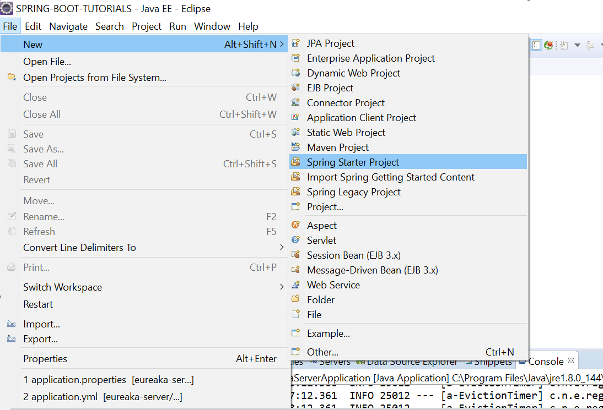
2. Then mention artifactid, groupid ,choose application type like war/jar and mention the package like below 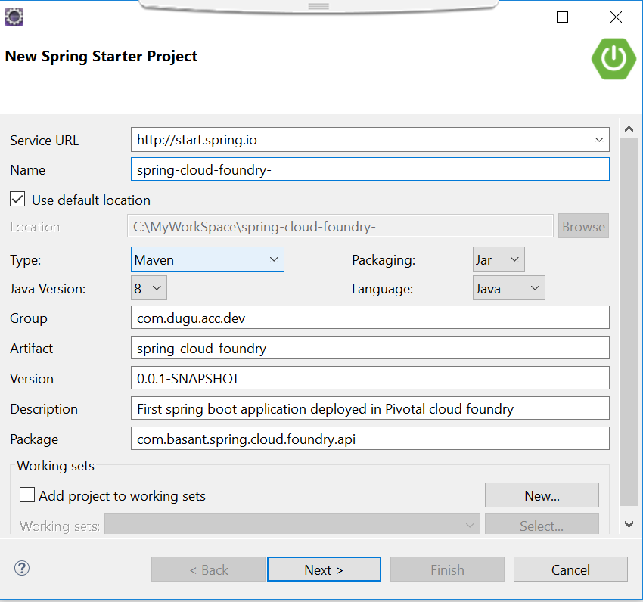
3. Click next then choose dependency to add , as am doing one small hello world project so I added only Web dependency like below 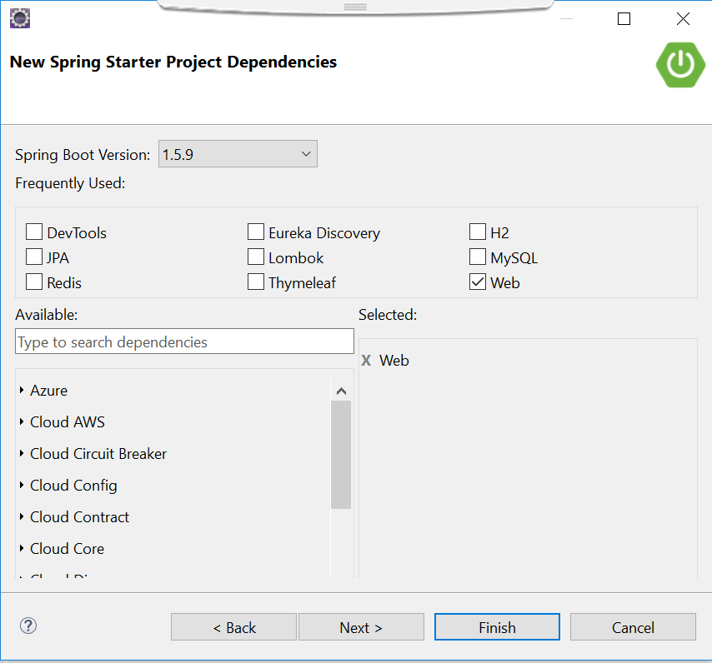
4. Click on finish your project will be imported to your eclipse , just open main class who contains main method and write one method which you want to expose on server u can create one more package and you can write separate controller class am just writing it in same class as am not going to perform any business in this app
5. Writing one method who will return String message as below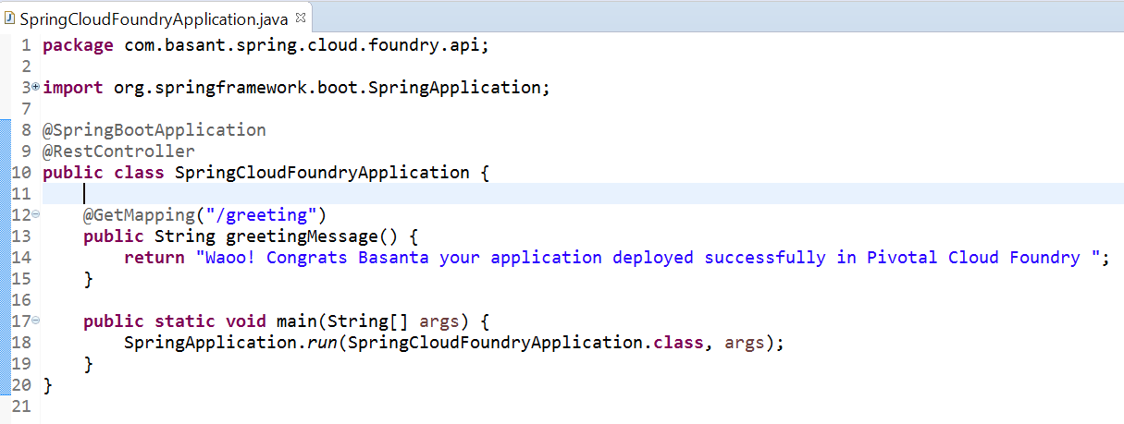
6. Then run your application in locally and test whether your API is working or not 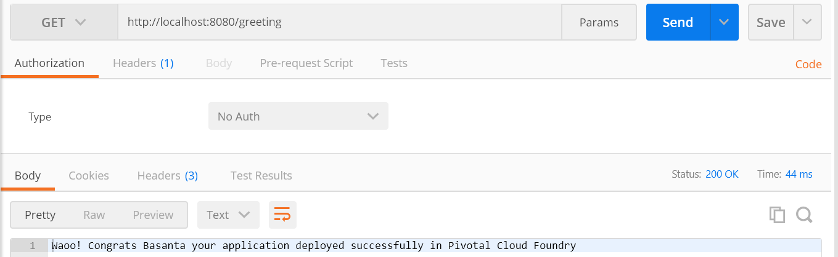its working am getting String message with stats code 200.
7. Now Pivotal don’t know which war or jar we are going to deploy and its path and what you want the application name on server and what memory you want to occupy to deploy your application on Cloud Foundry so for that we need to inform all in Cloud foundry using yml file name should be manifest.yml like below 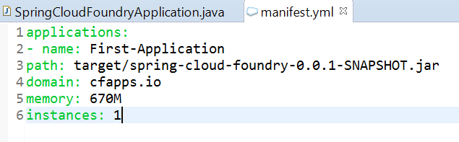
8. Let’s Deploy our application in Pivotal cloud foundry , so for that we need to login in Pivotal using CF-CLI Cloud Foundry Command line interface so go to the folder where you install your CLI then type command on that browser path like below 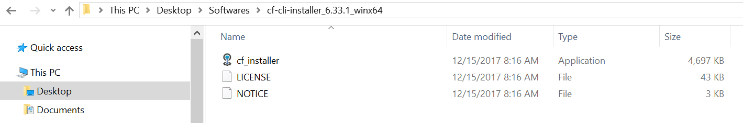
9. Then once you open command prompt type command cf login -a api.run.pivotal.io, then it will ask to enter email id and password which u used on sign up then follow that command like below 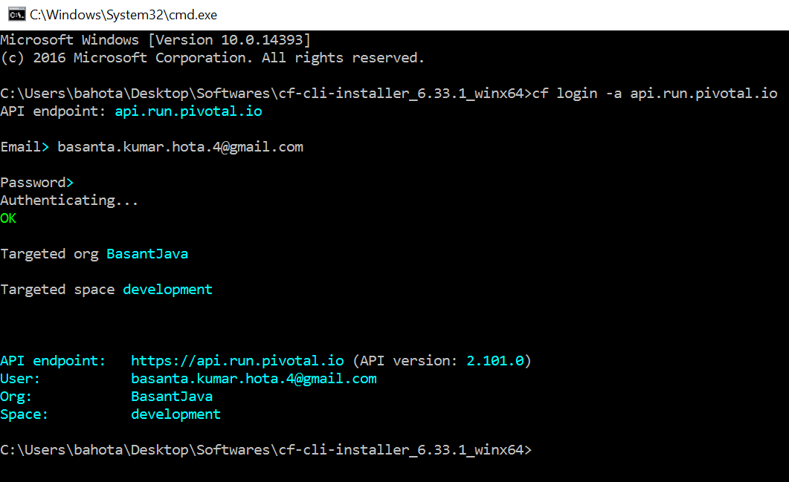See Authentication success and login to portal it display my organization name as BasantJava
10. Then now move to your project directory and open command prompt by pointing path to your project like below 
11. Then type command cf push ,it internally load your manifest.yml , from this file he will get the jar/war path then based on memory which u specified memory in yml file , same memory allocation happen on pivotal cloud foundry to deploy your application let’s run the command 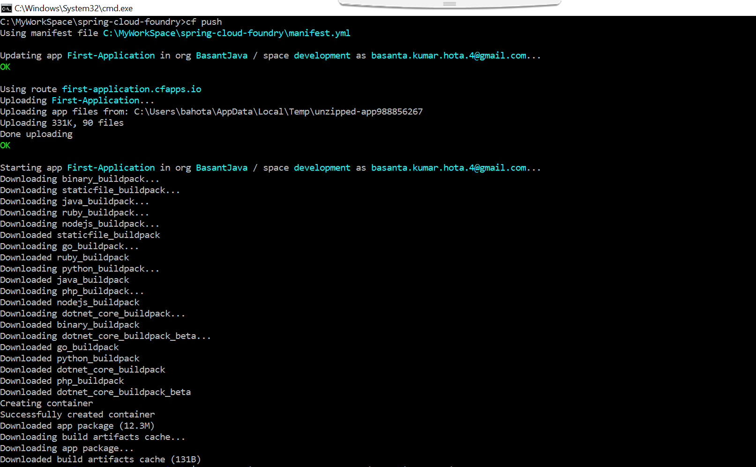see the command it build pack successfully now let’s see the metrics health of our Application in CLI 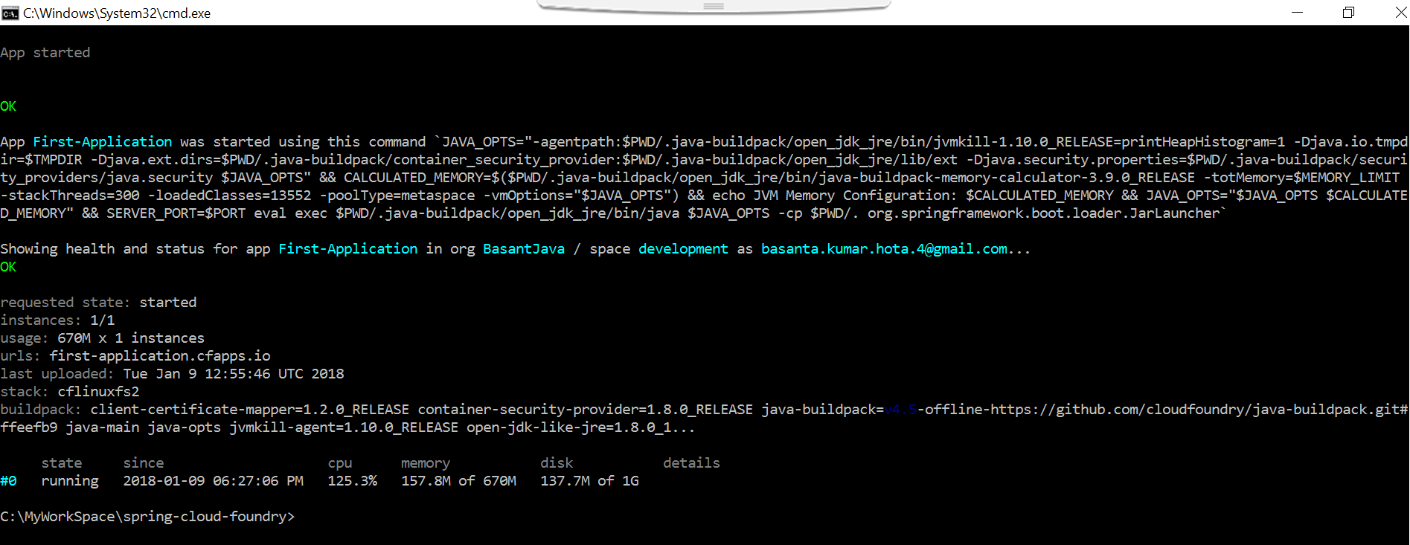

See the metrics now our application is start and deploy.

1. Now go to pivotal console and sign in again you will find your application is up and running there like below with occupy some space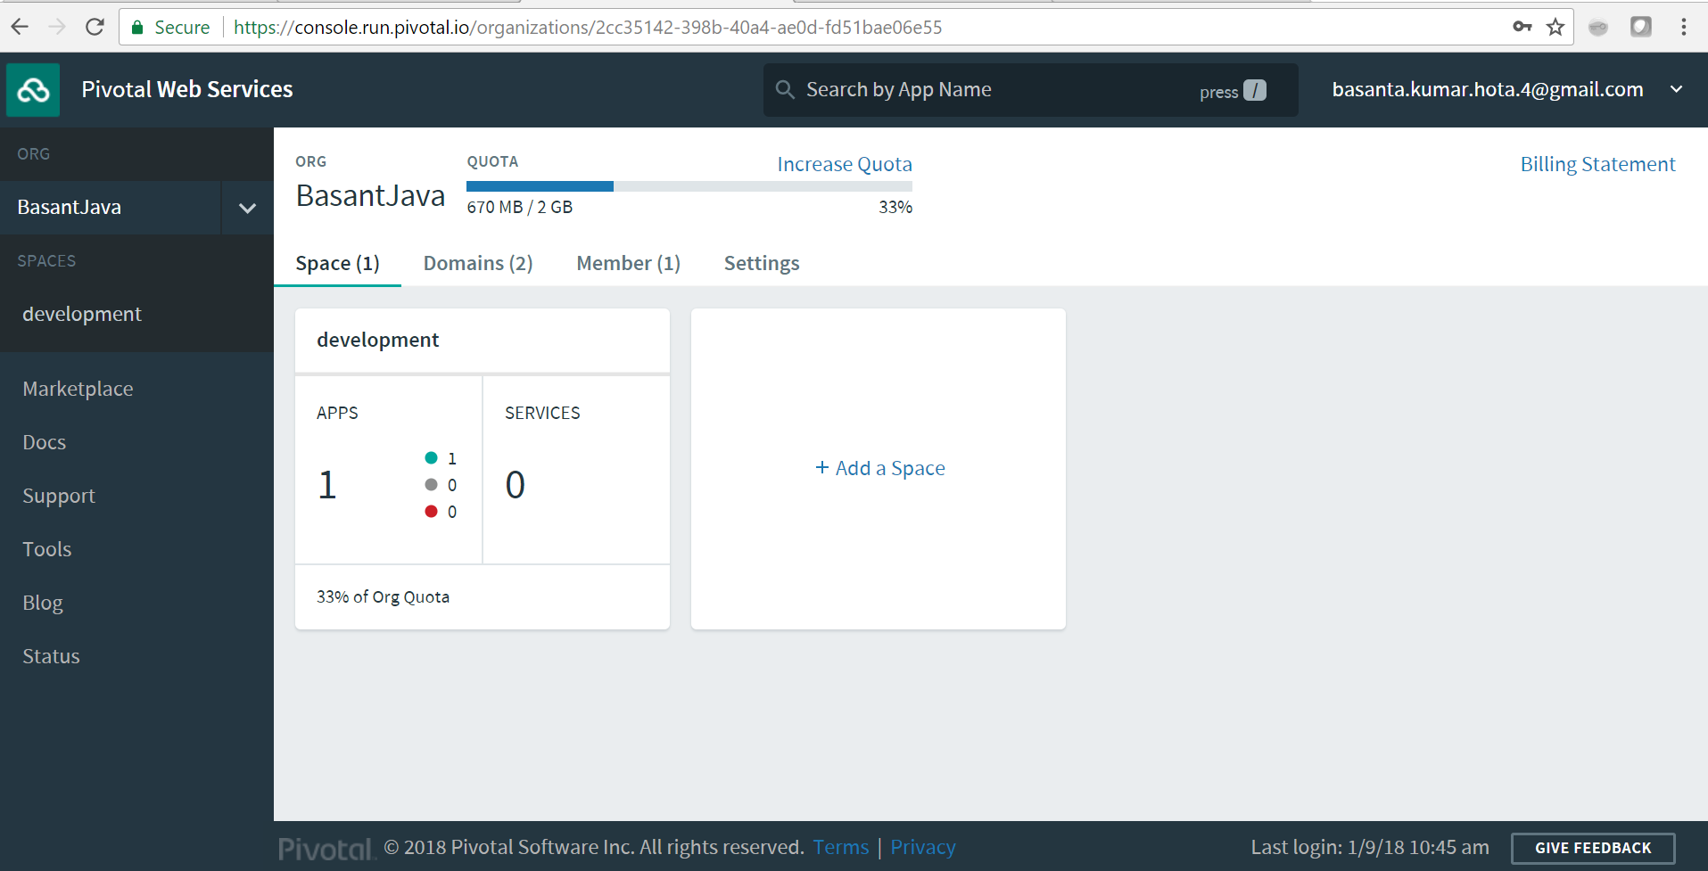see it occupy 670MB space from 2 GB , as I mention memory size in manifest.yml is 670MB
2. Now find the Application URL from development section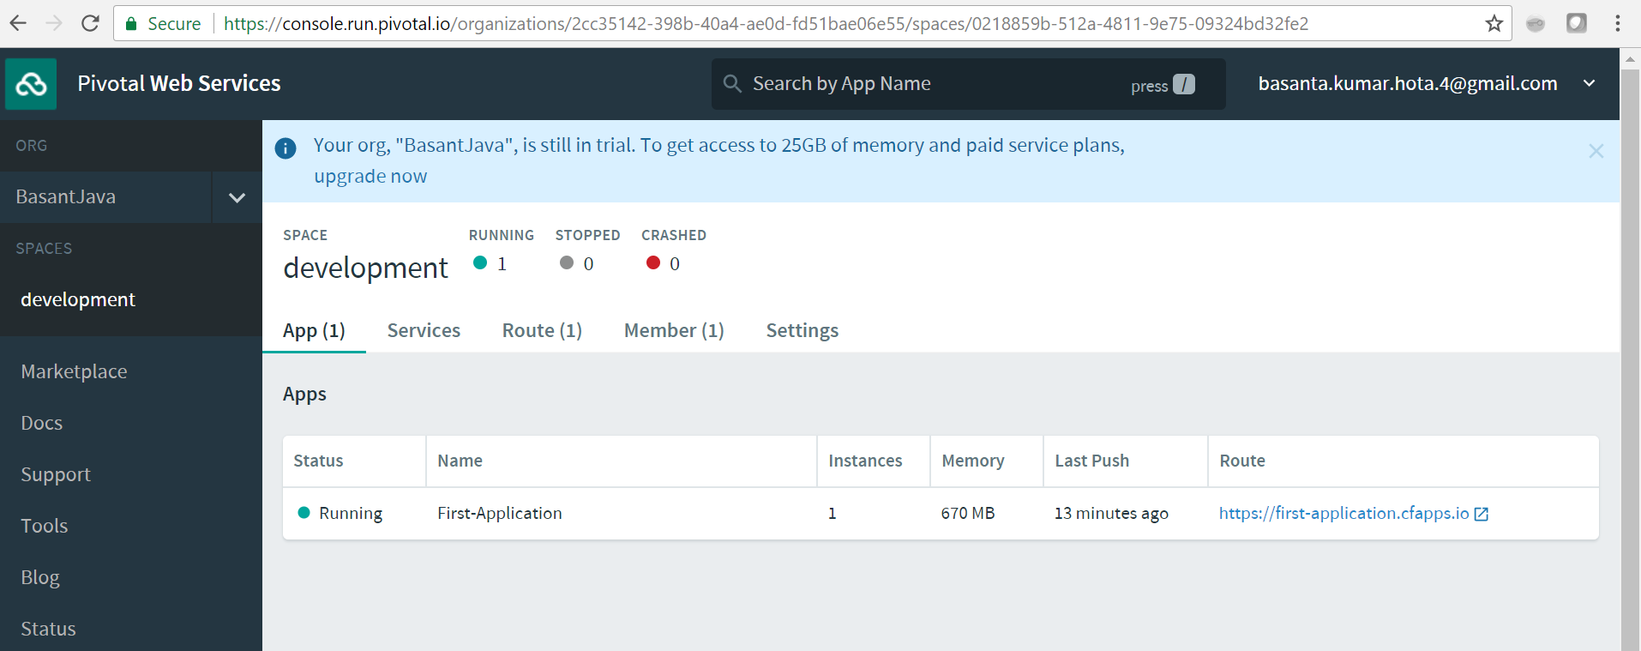see the right column Route copy that URL then append your endpoint URL and hit he URL to check whether our application deploy and working successfully
3. Response: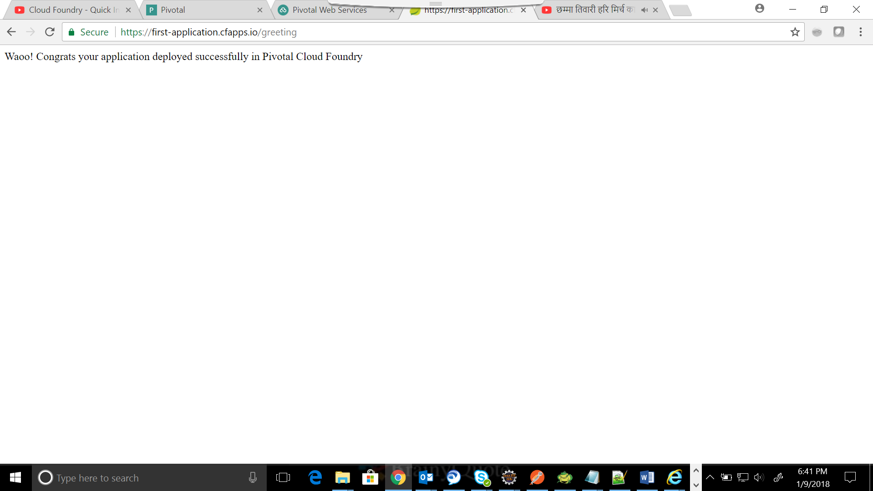Great we are good it’s working , This is the way we can deploy our service in Pivotal Cloud foundry , but I think you guys notice some difference between browser response and post man response , actually in post man it’s running in my local so what I did change it will reflect immediately , but I added Basant word in response latter and didn’t run maven install no new update jar available in target folder so it’s taking my old jar and same deployed .
4. Download => [Source Code](https://github.com/Sriman-Java-Gyan-Mantra/Spring-Cloud-Foundry)

Thanks,

Basanta Hota